Year 10 · Cambridge IGCSE

NAME

CLASS |  |  | DATE

COMPUTER SCIENCE 0478
Paper 2 Algorithms, Programming and Logic
Trace Tables: Exam Questions · MARK SCHEME about 1 hour 30 minutes
Teacher copy: completed trace tables are shown in red.

INSTRUCTIONS
- Answer all questions.
- Complete each trace table one step at a time. Only write a value in a column when that variable changes or a new value is input or output.
- Start a new row whenever you need to; you may not need every row.
- Calculators must not be used.

INFORMATION
- The total mark is 67.
- The number of marks for each question or part question is shown in brackets [ ].
- The questions use FOR, WHILE and REPEAT loops, IF and CASE selection, and one-dimensional arrays, in both pseudocode and flowcharts.

For teacher use
Question | 1 | 2 | 3 | 4 | 5 | 6 | 7 | 8 | Total
Marks | 6 | 7 | 7 | 7 | 8 | 11 | 9 | 12 | 67
Score

1 This section of program code may be used as a validation check.
Source: 0478/21 May/June 2019 Q4(a)–(c) (PRINT changed to OUTPUT, the current pseudocode keyword)
1 OUTPUT "Input a value between 0 and 100 inclusive"
2 INPUT Value
3 WHILE Value < 0 OR Value > 100 DO
4 OUTPUT "Invalid value, try again"
5 INPUT Value
6 ENDWHILE
7 OUTPUT "Accepted: ", Value
(a) Give a name for this type of validation check.
[1]
(b) Describe what is happening in this validation check.

[2]
(c) Complete the trace table for this program code using the test data:
200, 300, –1, 50, 60 [3]
Value | OUTPUT
 | Input a value between 0 and 100 inclusive
200 | Invalid value, try again
300 | Invalid value, try again
-1 | Invalid value, try again
50 | Accepted: 50

Marking points
(a) 1 mark:
- Range check
(b) Two from:
- The entered number (Value) is checked to see that it is not < 0 and not > 100
- If it is out of range it is rejected, an error message is displayed and the user has to enter another number
- Otherwise the number is accepted and ‘Accepted: ’ is output with the Value
(c) 3 marks:
- 1 mark: Value column
- 1 mark: OUTPUT column first line
- 1 mark: OUTPUT column lines two to five
- Note: 60 is never read, because the loop ends when 50 is accepted.
2 The pseudocode represents an algorithm.
Source: 0478/21 May/June 2022 Q5
The pre-defined function DIV gives the value of the result of integer division. For example, Y = 9 DIV 4 gives the value Y = 2
The pre-defined function MOD gives the value of the remainder of integer division. For example, R = 9 MOD 4 gives the value R = 1
First ← 0
Last ← 0
INPUT Limit
FOR Counter ← 1 TO Limit
INPUT Value
IF Value >= 100
THEN
IF Value < 1000
THEN
First ← Value DIV 100
Last ← Value MOD 10
IF First = Last
THEN
OUTPUT Value
ENDIF
ENDIF
ENDIF
NEXT Counter
(a) Complete the trace table for the algorithm using this input data:
8, 66, 606, 6226, 8448, 642, 747, 77, 121 [5]
Counter | Value | First | Last | Limit | OUTPUT
 |  | 0 | 0 | 8
1 | 66
2 | 606 | 6 | 6 |  | 606
3 | 6226
4 | 8448
5 | 642 | 6 | 2
6 | 747 | 7 | 7 |  | 747
7 | 77
8 | 121 | 1 | 1 |  | 121

(b) Describe the purpose of the algorithm.

[2]
Marking points
(a) One mark per mark point, max 5:
- MP1 correct Counter and Limit columns
- MP2 correct Value column
- MP3 correct First column
- MP4 correct Last column
- MP5 correct OUTPUT column
(b) One mark per mark point, max 2:
- checks for / outputs 3-digit numbers …
- … where the first and last digit are the same

Source: 0478/21 October/November 2022 Q4
3 This algorithm makes sure that there are enough fresh bread rolls available for customers to buy.
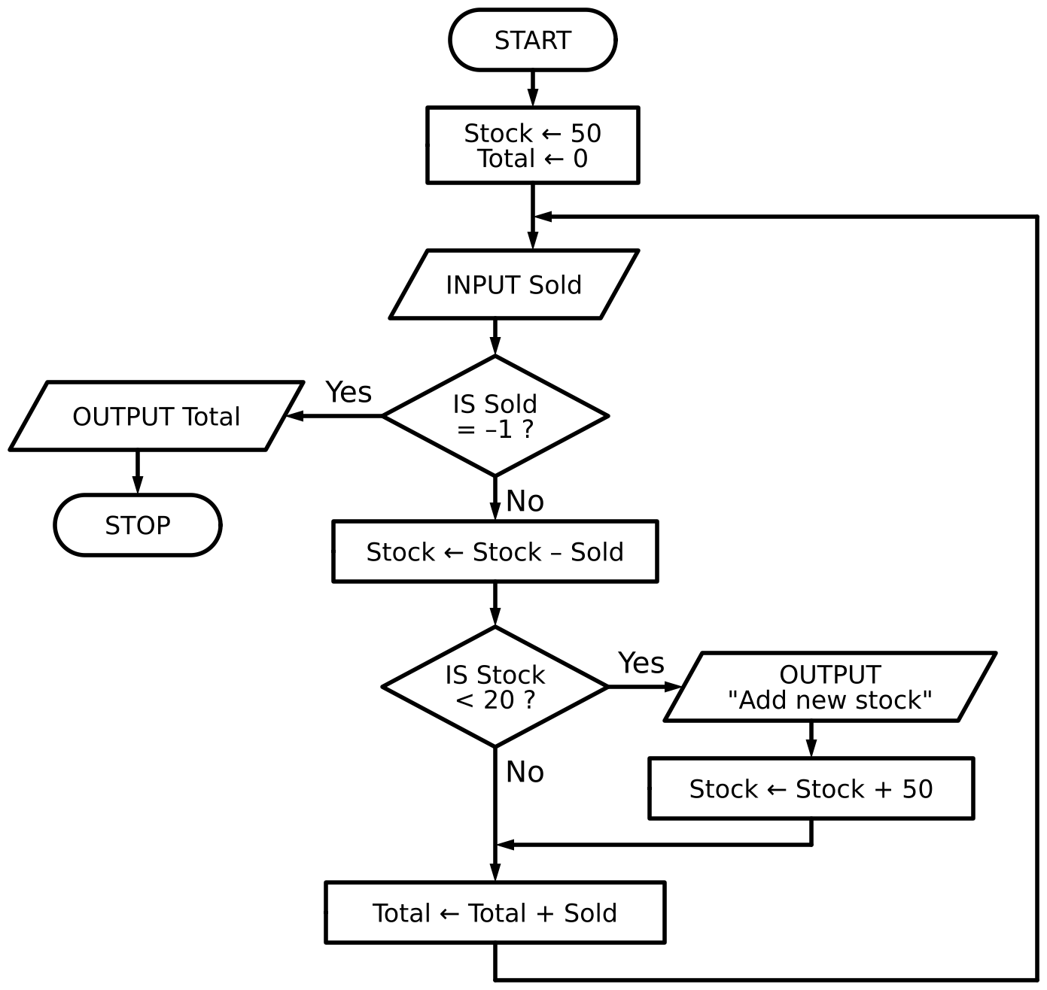
(a) Complete the trace table for the algorithm using this input data:
24, 12, 6, 30, 12, 18, –1, 24 [4]
Sold | Stock | Total | OUTPUT
 | 50 | 0
24 | 26 | 24
12 | 14 |  | Add new stock
 | 64 | 36
6 | 58 | 42
30 | 28 | 72
12 | 16 |  | Add new stock
 | 66 | 84
18 | 48 | 102
-1 |  |  | 102

(b) Identify the problem that will occur if the input data starts with a value of 70. Explain how you would correct this problem.

[3]
Marking points
(a) One mark for each correct column, max 4.
(b) One mark for identification of the error:
- the stock level will fall below zero / become negative
One mark per mark point, max 2:
- before subtracting the amount Sold from Stock …
- … test that the stock level / Stock is greater than the rolls to be sold / Sold
- provide a suitable error message / ask to re-input
4 The algorithm stores some examination marks in the array PassMarks.
Source: 0478/21 October/November 2019 Q4 (PRINT changed to OUTPUT)
Index ← 0
FOR Count ← 0 TO 7
INPUT Value
IF Value > 50
THEN
PassMarks[Index] ← Value
Index ← Index + 1
ENDIF
NEXT Count
OUTPUT "Number passed ", Index
(a) Complete the trace table for this algorithm using the input data:
58, 40, 67, 85, 12, 13, 75, 82 [6]
Index | Count | Value | PassMarks |  |  |  |  |  |  |  | OUTPUT
Index | Count | Value | [0] | [1] | [2] | [3] | [4] | [5] | [6] | [7] | OUTPUT
0
1 | 0 | 58 | 58
 | 1 | 40
2 | 2 | 67 |  | 67
3 | 3 | 85 |  |  | 85
 | 4 | 12
 | 5 | 13
4 | 6 | 75 |  |  |  | 75
5 | 7 | 82 |  |  |  |  | 82
 |  |  |  |  |  |  |  |  |  |  | Number passed 5

(b) Give the purpose of the algorithm shown in part (a).

[1]
Marking points
(a) 6 marks:
- The published scheme gives the completed table only. Suggested split: 1 mark each for the Index, Count and Value columns; 1 mark PassMarks[0]–[1]; 1 mark PassMarks[2]–[4]; 1 mark OUTPUT.
- Accept Index written on the row before it is incremented, provided the values are in the right order.
(b) One from:
- Stores numbers greater than 50 in an array
- Outputs the number of times the pass mark has been met
- Finds the number of pass marks

Source: 0478/23 October/November 2023 Q8
5 This is an algorithm to find if a batch of parts has been manufactured successfully.
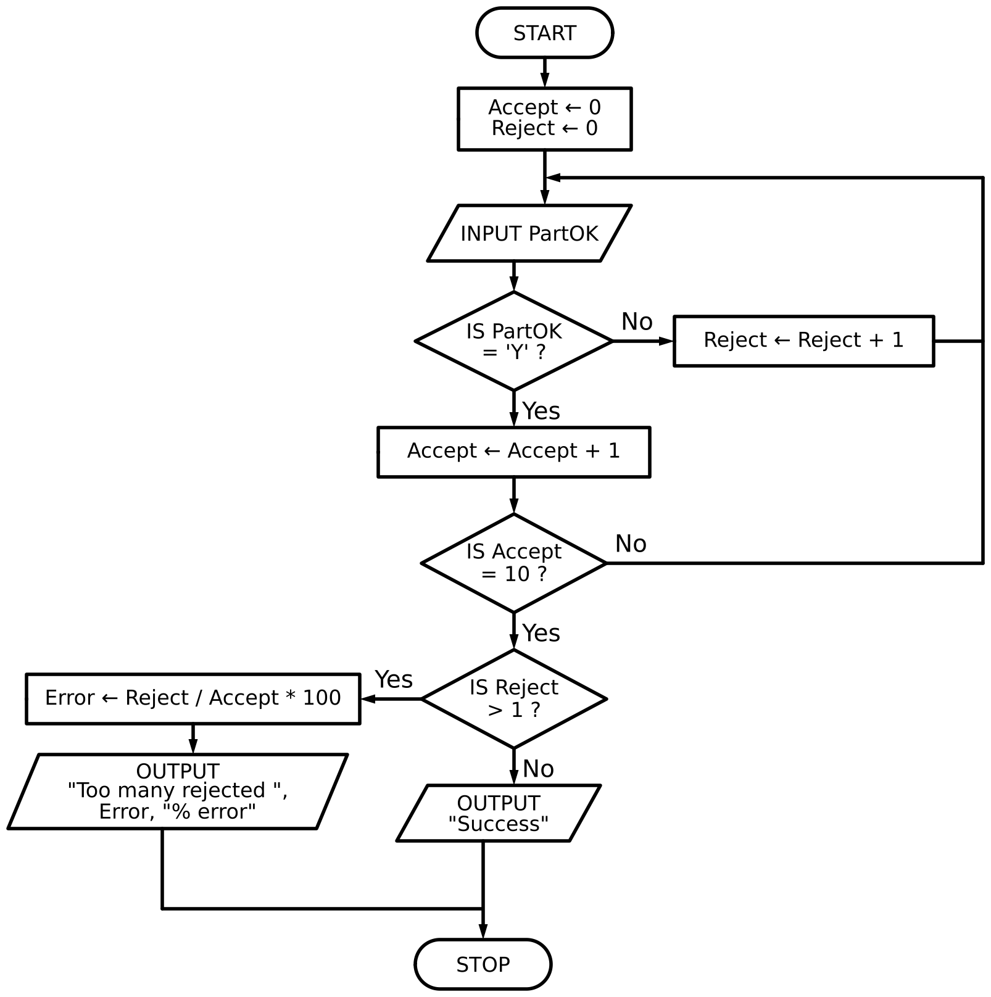
(a) Complete the trace table using this data:
Y, Y, Y, N, Y, Y, Y, Y, N, Y, Y, Y, Y [5]
Accept | Reject | PartOK | Error | OUTPUT
0 | 0
1 |  | Y
2 |  | Y
3 |  | Y
 | 1 | N
4 |  | Y
5 |  | Y
6 |  | Y
7 |  | Y
 | 2 | N
8 |  | Y
9 |  | Y
10 |  | Y
 |  |  | 20 | Too many rejected 20% error

(b) Describe how the algorithm should be changed to accept ‘Y’ or ‘y’ for a successfully manufactured part.

[3]
Marking points
(a) One mark for each column, max 5.
(b) One mark for each point, max 3:
- after the INPUT box // before the first decision box …
- … insert a process box …
- … to convert the input to upper case
OR
- change the first decision / add another decision box …
- … to accept ‘y’ as well …
- … by adding OR PartOK = ‘y’

Source: Exam-style question written for this worksheet (none of the unused past-paper trace questions uses a CASE statement without string functions)
6 A clothes shop uses this algorithm to count the sizes of T-shirts sold in a day.
Each size is input as a single character. An input of 'X' ends the input.
DECLARE Size : CHAR
DECLARE Index : INTEGER
DECLARE Total : ARRAY[1:4] OF INTEGER
FOR Index ← 1 TO 4
Total[Index] ← 0
NEXT Index
REPEAT
INPUT Size
CASE OF Size
'S' : Total[1] ← Total[1] + 1
'M' : Total[2] ← Total[2] + 1
'L' : Total[3] ← Total[3] + 1
OTHERWISE : Total[4] ← Total[4] + 1
ENDCASE
UNTIL Size = 'X'
FOR Index ← 1 TO 3
OUTPUT Total[Index]
NEXT Index
OUTPUT "Invalid: ", Total[4]
(a) Complete the trace table for the algorithm using this input data:
M, L, M, S, Q, M, X, S [6]
Index | Size | Total |  |  |  | OUTPUT
Index | Size | [1] | [2] | [3] | [4] | OUTPUT
1 |  | 0
2 |  |  | 0
3 |  |  |  | 0
4 |  |  |  |  | 0
 | M |  | 1
 | L |  |  | 1
 | M |  | 2
 | S | 1
 | Q |  |  |  | 1
 | M |  | 3
 | X |  |  |  | 2
1 |  |  |  |  |  | 1
2 |  |  |  |  |  | 3
3 |  |  |  |  |  | 1
 |  |  |  |  |  | Invalid: 2

(b) State the purpose of the algorithm.

[2]
(c) There is a logic error in the algorithm. The final output is one more than the number of invalid sizes that were input.
Identify the cause of the error and describe how the algorithm could be corrected.

[3]
Marking points
(a) One mark per mark point, max 6:
- MP1 Index column 1 to 4 with Total[1]–[4] set to 0
- MP2 Size column M, L, M, S, Q, M, X (the final S is never read)
- MP3 Total[1] and Total[2] columns (S = 1; M = 1, 2, 3)
- MP4 Total[3] column (L = 1)
- MP5 Total[4] column 1 then 2 (Q and X)
- MP6 OUTPUT 1, 3, 1, Invalid: 2 (with the second Index 1 to 3)
(b) One mark per mark point, max 2:
- counts how many of each size (S, M, L) are sold / input …
- … and counts the number of invalid sizes input
- outputs the totals
(c) One mark per mark point, max 3:
- the terminating value ‘X’ is processed by the CASE statement …
- … so it falls into OTHERWISE and is counted as an invalid size
- add a case for ‘X’ that does nothing // check IF Size <> ‘X’ before the CASE statement
- OR output Total[4] – 1 // subtract 1 from Total[4] after the loop
- OR use a WHILE loop / input the first size before the loop and the next size at the end of the loop, so X is checked before it is counted

Source: 0478/22 May/June 2022 Q4
7 This algorithm checks the temperature of hot food being served to customers.
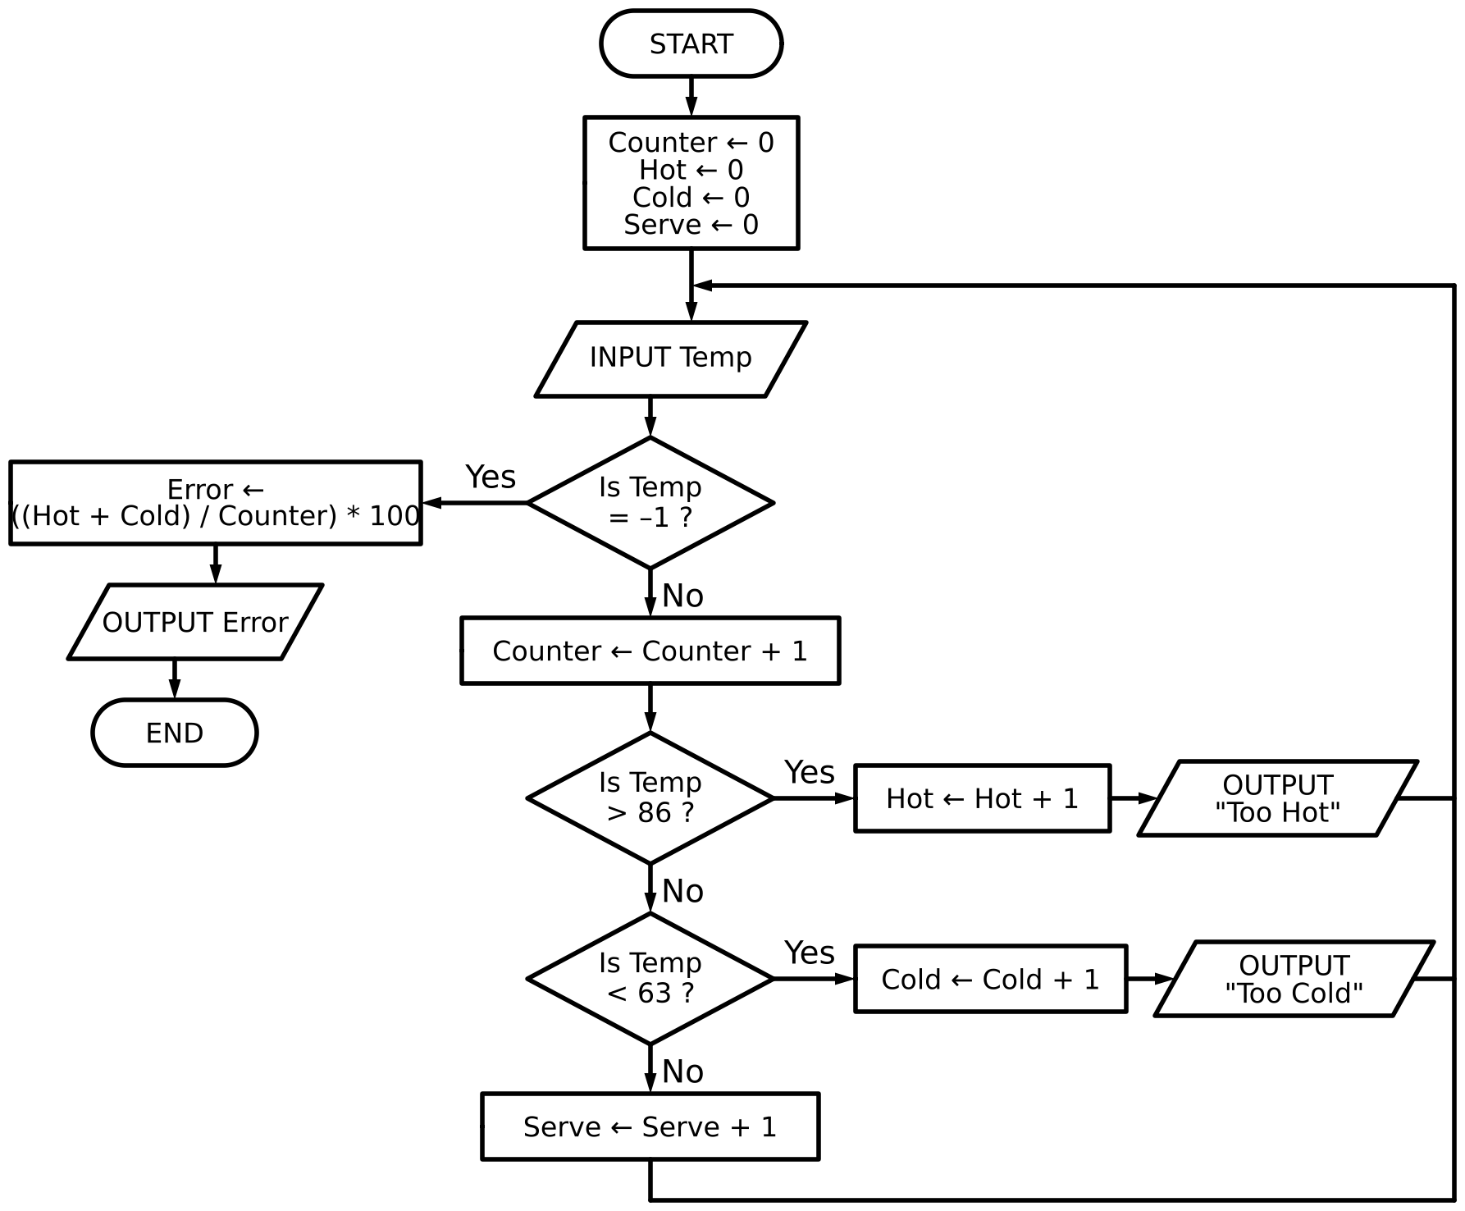
(a) Complete the trace table for the algorithm using this input data:
75, 78, 84, 87, 91, 80, 75, 70, 65, 62, –1, 20 [7]
Counter | Hot | Cold | Serve | Temp | Error | OUTPUT
0 | 0 | 0 | 0
1 |  |  | 1 | 75
2 |  |  | 2 | 78
3 |  |  | 3 | 84
4 | 1 |  |  | 87 |  | Too Hot
5 | 2 |  |  | 91 |  | Too Hot
6 |  |  | 4 | 80
7 |  |  | 5 | 75
8 |  |  | 6 | 70
9 |  |  | 7 | 65
10 |  | 1 |  | 62 |  | Too Cold
 |  |  |  | -1 | 30
 |  |  |  |  |  | 30

(b) State how the final output from the algorithm could be improved.

[1]
(c) Identify the process in the algorithm that is not required.
[1]
Marking points
(a) One mark for each correct column, max 7.
- Counter is not incremented for the rogue value –1; Error = (2 + 1) / 10 * 100 = 30; 20 is never read.
(b) 1 mark:
- include a message to explain the value output, e.g. “The percentage of meals not served” // output Hot, Cold and Serve as well
(c) 1 mark:
- updating the Serve variable // Serve ← Serve + 1

Source: 0478/23 May/June 2022 Q4
8 The pseudocode represents an algorithm.
The pre-defined function DIV gives the value of the result of integer division. For example, Y = 11 DIV 4 gives the value Y = 2
Count ← 0
INPUT Limit
FOR In ← 1 TO Limit
Logic ← TRUE
Test ← 2
INPUT Number
REPEAT
IF Number / Test = Number DIV Test
THEN
Logic ← FALSE
ELSE
Test ← Test + 1
ENDIF
UNTIL NOT Logic OR Test >= Number DIV 2
IF Logic
THEN
Store[Count] ← Number
Count ← Count + 1
ENDIF
NEXT In
FOR Out ← 0 TO Count - 1
OUTPUT Store[Out]
NEXT Out
(a) Complete the trace table for the algorithm using this input data:
5, 9, 5, 8, 10, 7 [7]
In | Logic | Test | Number | Store[Count] | Count | Limit | Out | OUTPUT
 |  |  |  |  | 0 | 5
1 | TRUE | 2 | 9
 |  | 3
 | FALSE
2 | TRUE | 2 | 5
 |  | 3
 |  |  |  | 5 | 1
3 | TRUE | 2 | 8
 | FALSE
4 | TRUE | 2 | 10
 | FALSE
5 | TRUE | 2 | 7
 |  | 3
 |  |  |  | 7 | 2
 |  |  |  |  |  |  | 0 | 5
 |  |  |  |  |  |  | 1 | 7

(b) State the purpose of this algorithm.

[2]
(c) This algorithm only works for numbers that are 3 or greater. Describe how you could change this algorithm to make sure that only numbers that are 3 or greater are entered. Any pseudocode statements used in your answer must be fully described.

[3]
Marking points
(a) One mark per mark point, max 7:
- MP1 correct In column
- MP2 correct Logic column
- MP3 correct Test column
- MP4 correct Number column
- MP5 correct Store[Count] column
- MP6 correct Count and Limit columns
- MP7 correct Out and OUTPUT columns
(b) One mark per mark point, max 2:
- to find / output prime numbers …
- … and store the prime numbers in an array
(c) One mark per mark point, max 3:
- MP1 insert a WHILE loop … // pre-condition loop
- MP2 … after INPUT Number
- MP3 … with a condition to enter the loop: Number < 3
- MP4 an error message within the loop asking for Number to be re-entered
- MP5 … with another input for Number
- MP6 ENDWHILE closes the loop and the program carries on from REPEAT in the original algorithm
OR
- MP1 insert a REPEAT loop … // post-condition loop
- MP2 … around INPUT Number
- MP3 an error message if Number < 3
- MP4 UNTIL Number >= 3

END OF QUESTIONS

